Developing an open, national-level, small-area geodemographic classification of consumer behaviour.
Purpose: This study fills a gap in consumer insight by developing an open, national small-area geodemographic classification. Existing frameworks overlook localised variations and fail to integrate consumer surveys. Our approach delivers a geodemographic classification of consumer behaviour across England and Wales.
Study design: We integrated the PDV Consumer Lifestyle Survey, 2021 Census, and built-environment accessibility metrics. Spatial microsimulation is used created synthetic populations at the Lower Super Output Area level, aligning individual attributes with PDV data to produce small-area estimates. Eight analytical domains were derived from a conceptual frame which is then used to define an iterative variable selection. We then apply clustering to demographic and demand variables to derive primary and sub-clusters of consumer behaviour.
Findings: Four clusters emerged, each with distinct demand and demographic profiles. Affluent Professional Consumers, Budget-Conscious Young Urbanites, Family-Oriented Suburban Consumers, and Traditional Rural Consumers form the main clusters, then nine further subclusters are derived. Results underscore how the domains derived from the conceptual framework shape small‐area patterns.
Value: Insights can inform targeted policy interventions and retail investment strategies by highlighting the spatial distribution of consumer needs. Opportunities for improving retail centre accessibility, fostering digital inclusion, and tailoring product offerings can be derived. This classification lays the groundwork for future methodological advances, such as the use of agent-based modelling to simulate dynamic consumer–retail interactions.
Keywords: Consumer Behaviour, Geodemographic Classification, Spatial Analysis, Clustering, Retail
1.Introduction
Consumer shopping behaviours have become increasingly dynamic, shaped by technological advancements and shifting lifestyle priorities (Singh et al., 2024). The rise of digital platforms, and personalised recommendations has empowered consumers to tailor their retail experiences across channels (Dolega et al., 2021, Ntounis et al., 2023). Furthermore, sustainability, the cost-of-living crisis, and flexible working, have further influenced these behaviours, with shoppers increasingly seeking convenience, eco-friendly options, value-for-money and delivery services (Wrigley and Lambiri, 2015; Ntounis et al., 2023). Therefore, consumer behaviour, and the way in which it is shifting, is becoming increasingly complex and multi-dimensional.
Understanding these behavioural shifts is essential for urban planners and retail managers for interventions, ensuring that physical retail spaces remain competitive in this landscape. Physical retail spaces, traditionally hubs of community activity and economic transactions, have faced growing pressure, compelling them to redefine their value propositions by enhancing consumer experiences and adapting to expectations (Ntounis et al., 2023; White et al., 2023). Recent research has demonstrated the wider social and cultural role that retail destinations fulfil (Davies et al., 2019; Ballantyne et al., 2023), which is in part in response to the evolving needs and behavioural shifts of the modern consumer. Henceforth, physical retail spaces continue to rapidly transform in response to trends– notably its technological, economic, social, environmental and cultural components. These changes require decision-makers to understand how behaviour varies spatially in response to accessibility, digital capability, and lifestyle practices.
Henceforth, to conceptualise and understand how consumer behaviour is changing, it is vital to consider the influence that different spatially varying, interacting factors have on these shifts. There is a well-established literature which explores the associations between different personal/behavioural attributes and purchasing behaviours. For example, characteristics such as household composition, socioeconomic status, lifestyle attributes, physical and digital accessibility, and online usage patterns accessibility (Fernie and Sparks, 2018; Gauri et al., 2020; Belwal et al, 2025; Radomska et al., 2025; Zhang et al., 2025) have been studied. Together, these attributes (and many others), often combine in complex ways to influence purchasing priorities, preferences, and channel selection. However, much existing work and many national geodemographic classifications continue to treat these dimensions separately or assume that consumer behaviour is largely an outcome of socioeconomic structure (i.e Gale et al., 2016; Butterfield et al., 2020; Cocking et al., 2020). To unpack these evolving dynamics, it is therefore critical to analyse each factor and how they intersect and vary across space, revealing the underlying mechanisms that drive decision-making. From an analytical perspective, capturing the multidimensionality and spatial variation of modern consumer behaviour is challenging, given these dimensions span multiple domains (e.g., socioeconomic, digital), and operate at varying spatial scales. A proven technique in both academic and industrial applications is the use of geodemographics, whereby demographic, spatial and behavioural factors can be combined to identify groups of sharing behaviours (Lemon and Verhoef, 2016; Belwal et al., 2025).
The purpose of this study is to develop an openly available, national-level, small-area geodemographic classification dataset that captures the multidimensional nature of consumer behaviour across England and Wales. Unlike earlier classifications, which have largely centred on socioeconomic structure, this study advances a theoretically grounded framework in which demographic, behavioural, digital, and accessibility dimensions are treated as co-determining drivers of consumer behaviour. This approach offers a refined conceptual lens for understanding how multiple domains collectively shape contemporary consumption patterns. To achieve this, we cluster consumers to better understanding the complexity and multidimensionality of consumers, through integrating an array demographic and socioeconomic, physical accessibility and spatial context, and digital and behavioural factors, that have not before been combined in an openly available geodemographic classification. Through this contribution, the study extends existing geodemographic approaches by generating new empirical insight into how consumer behaviour varies spatially beyond what can be inferred from census-based classifications, delivering a small-area consumer classification for England and Wales.
The classification, which is developed at the Lower Super Output Area (LSOA) level, is underpinned by complex analytical components, such as the microsimulation of a proprietary consumer behavioural survey, aforementioned demographic factors and accessibility measures. By bringing together measurable characteristics and information that capture the complexity of modern consumer behaviour, the classification produces actionable consumer typologies that reveal how behavioural, digital, and spatial factors intersect geographically and advances theoretical understanding of fine-grained consumer-retail dynamics.

2. Literature Review
To conceptualise and measure consumer behaviour with a multidimensional, spatial perspective, we examine the existence and interactions between the dimensions of demographic and socioeconomic, physical accessibility and spatial context, and digital and behavioural factors that drive consumer decisions. This review identifies existing knowledge and research gaps concerning the integration of these dimensions into spatial consumer behaviour classifications
2.1 Demographic and Socioeconomic
Household size is a key domain which impacts consumer behaviour. Larger households typically exhibit different purchasing habits (Hossain., 2020), often driven by the need for savings. Financial factors are also a key domain, with income levels influencing both the quantity and type of purchases; higher-income households tend to favour luxury goods and premium services, while lower-income groups focus on necessities (Belwal et al. 2025). However, income alone does not determine purchasing patterns; financial management practices, such as budgeting and investments, also shape resource allocation (Negi and Jaiswal, 2024). Socioeconomic status is a key domain of purchasing power and consumption patterns. For instance, Belwal et al. (2025) demonstrate that variations in income, employment, and occupational status influence the purpose of shopping trips, underscoring the critical role of socioeconomic status in shaping consumer behaviour. Furthermore, research indicates lower socioeconomic status influences attitudes towards forms of retail, brands and luxury items (Tangri and Yu, 2023), suggesting greater financial stability equals more diversified behaviours. While these studies establish the importance of socioeconomic factors, they explain consumption through structural position, offering limited insight into how behaviour varies spatially or interacts with accessibility and digital engagement.
Age is a critical domain which influences consumer priorities. Millennials often engage in showrooming as a strategy to reduce perceived risk and maximise convenience, particularly in relation to product and financial decisions (Johnson and Ramirez, 2020). While Belwal et al. (2025) prioritise structural socioeconomic position a driver of behaviour, Sharma and Dutta, (2025) suggest life stages influence spending habits: Gen-Z values quality and affordability, Gen-Y shows brand loyalty and premium preferences, while Gen-X demonstrates a decline in brand allegiance (Sharma & Dutta, 2025). Furthermore, as age increases, expenditure on leisure and recreational activities increases, often replacing work-related and necessity-based spending.
Furthermore, as age increases, expenditure on leisure and recreational activities increases, often replacing work-related and necessity-based (Schwendtner et al. 2024). This creates tension between economic status and life stage priorities, a gap which this study addresses by synthesising both into a single framework. Moreover, married individuals are more likely to engage in online shopping to manage shared responsibilities and household needs (Rybaczewska and Sparks, 2022). However, these studies typically focus on individual or household behaviour, rather than examining how such patterns cluster spatially or interact with retail environments.
2.2 Physical Accessibility and Spatial Context
Gauri et al. (2020) and Stevens et al. (2021) present divergent ideas of accessibility: where urban proximity foster impulsive, premium consumption; rural constraints necessitate calculated, utility-driven planning. For instance, households in highly accessible areas show higher demand for premium products and make impulse purchases, while those in less accessible areas tend to plan shopping trips (Gauri et al., 2020). Accessibility also affects leisure and recreational retail, as consumers with better access to dining and social venues to engage more frequently, reinforcing the role of location in shaping consumption (Barboza et al. 2024).Accessibility is rarely integrated with behavioural and demographic data in national geodemographic classifications, limiting its usefulness for decision-making.
2.3 Digital and Behavioural
Online retail has transformed consumer behaviour by changing how individuals’ access and interact with retail, making it a critical domain. Internet connectivity and digital literacy are now essential to e-commerce participation, allowing for price comparison and convenient purchasing (Davies et al. 2019; Singleton et al. 2020; Amsl et al. 2023). Furthermore, individuals with higher levels of digital literacy are more likely to adopt online retailing, shifting away from traditional brick-and-mortar retailers (Radomska et al., 2025) or click-and-collect being attractive for time-sensitive individuals (Fernie and Sparks, 2018, Davies et al., 2019). Retail-focused research highlights the strategic importance of omnichannel behaviour for store networks, but often relies on firm-specific transaction data, limiting generalisability and spatial coverage.
2.4. Interactions and Conceptualisation
Together, demographic and socioeconomic, physical accessibility and spatial context, and digital and behavioural factors, do not operate in isolation, but instead exert mutual influence over consumer decision-making. For example, car dependency illustrates the interdependence between demographic and spatial factors, with larger households (a demographic trait) more likely to own and rely on private vehicles, especially in areas with limited public transport or dispersed retail provision (a spatial constraint). Similarly, financial capacity influences transport choices (socioeconomic), which affects shopping behaviours like bulk buying, fewer but larger trips (behavioural), and reliance on local versus regional stores. These overlapping influences demonstrate that consumer decisions are shaped not just by preferences, but by a web of enabling and constraining conditions.
To conceptualise this complexity, Figure 1 presents a framework illustrating the intersections between dimensions and the domains within. The overlapping spaces represent areas where domains converge to influence consumer behaviour. This framework serves to understand how these dimensions interact dynamically to shape behaviour. Much of the existing literature and classifications treats these domains separately, resulting in fragmented theoretical perspectives. This study contributes conceptually by proposing and operationalising a multidimensional framework that links demographic, spatial, digital, and behavioural dimensions, thereby offering a holistic depiction of consumer–retail interaction.
Add-Figure-1-here 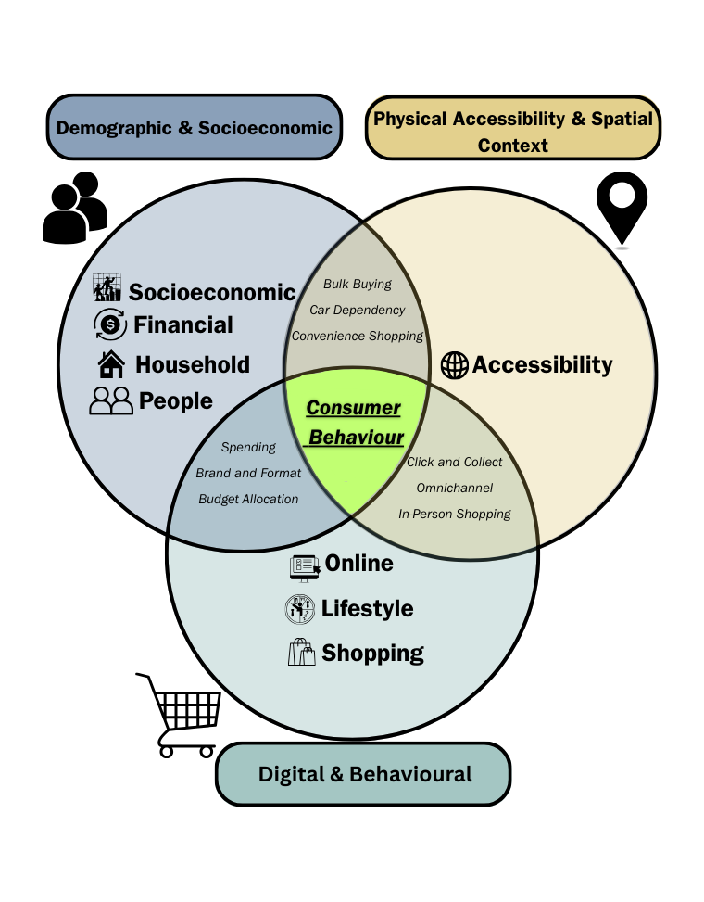
2.5 Geodemographic Classification
Measuring the multidimensional complexity of modern consumer behaviour requires an integrated framework that captures diverse influencing factors. Geodemographic classification is a powerful tool to capture multidimensional spatial phenomena, grouping geographic areas based on shared characteristics (Singleton and Spielman, 2014). The process begins with defining a clear objective, collection of data and variables for components specified in new or pre-existing theoretical frameworks and applying cluster analysis to partition the data into distinct groups based on the similarity of their attributes (Singleton et al. 2020). Within the retail sector, geodemographic classifications are applied to segment consumers, to capture the complexity of human behaviours across different geographic contexts and enable the identification of areas where consumers exhibit particular behaviours, making them vital for both retail managers, for store network planning, merchandising and omnichannel strategy (Singleton and Spielman, 2014; Silva et al. 2024, Yang and Hu, 2024), and planners for interventions. Moreover, emerging research demonstrates that spatial and behavioural segmentation can reveal underserved catchments and demand patterns that are not apparent from traditional demographic or proximity measures alone, helping retailers prioritise investment and optimise location decisions (Guan et al., 2025).
General-purpose classifications such as the UK’s Output Area Classification (OAC) and Mosaic (Gale et al., 2016; Singleton and Spielman, 2014), are effective, but these systems tend to generalise across large populations, missing the nuances of specific population segments (Gray et al., 2021). In contrast, bespoke classifications, tailored to needs or sectors offer a more detailed understanding of specific population behaviours, often through integration of innovative data sources (Butterfield et al. 2020; Singleton et al. 2020). For example, the Internet User Classifications (IUC) identifies digital engagement levels across regions to address digital inequalities (Singleton et al., 2020) and the Ageing in Place Classification (AiPC) groups areas based on the density and needs of older adults, supporting policymaking in healthcare (Yang et al., 2023).
A critical trade-off exists between open and commercial systems: general-purpose classifications offer transparency but lack behavioural depth (Gray et al., 2021), while commercial systems like Mosaic offer depth but remain 'black boxes' with limited academic replicability. By contrast, our study bridges this divide, utilising the transparency of open data while capturing the behavioural and digital nuances typical of proprietary models. Consequently, we address the gap identified by Lemon and Verhoef (2016) regarding the integration of digital engagement into spatial retail frameworks
Together, this shows lack of an openly available tools that capture the full complexity of consumer behaviour both theoretically and practically, including how purchasing decisions emerge from the interaction of the domains identified above. Therefore, there is a clear need for a theoretically grounded, geodemographic framework that can integrate diverse data sources to generate actionable insights about the complexity of consumer behaviour. It would provide policymakers and retailers managers with localised insights about how consumers are behaving in different areas to support efforts to target the decline of physical retail spaces (Dolega and Lord, 2020; Ntounis et al., 2023; Yang and Hu, 2024), and allocate resources and services. This contribution is not only methodological but also theoretical: it demonstrates how multidimensional consumer behaviour can be spatially operationalised, advancing the field beyond demographically dominated approaches and offering new insights for planners, policymakers, and the retail sector.
3. Methodology
Our approach to generate a geodemographic classification of consumer behaviour draws from established frameworks (Gale et al., 2016; Singleton et al., 2020; Yang et al., 2023; Gale et al., 2016). An overview of the stages is below:
Add-Figure-2-here
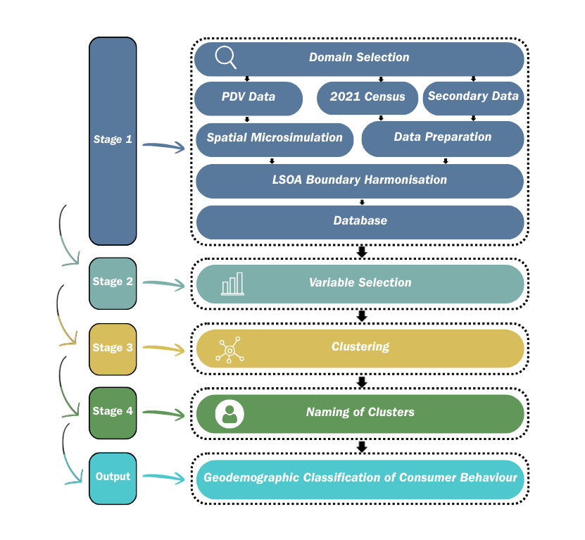
3.1 Stage 1 - Domain selection
The first stage of a geodemographic classification involves identification of relevant domains to ensure alignment with the phenomena being investigated (i.e. consumer behaviour). To achieve this, a literature review was conducted, ensuring that the domains were grounded in evidence and relevant to the objectives. This approach facilitated the inclusion of variables most representative of consumer behaviour. The literature in this review provided 8 domains for consumer behaviour: Household Composition, Financial, Lifestyle, Mobility, Online Engagement, People, Shopping Behaviour, and Socioeconomic Status.
3.2. Stage 2 – Variable Selection
3.1.1 Data
First the PDV Consumer Lifestyles DLG Dataset (CDRC, 2023) was identified as the key source for variables related to the behavioural and socioeconomic domains within the conceptual framework. This dataset contains over 15 million responses (2001–2023) across 515 variables related to consumer shopping, lifestyle, and financial behaviour. The diversity in variables captures multiple aspects of population characteristics and ensures the classification is widely applicable (Gale et al., 2016). However, the PDV dataset is a self-reported survey, which can introduce response bias and its longitudinal nature raises concerns about temporal inconsistency, as behaviours may evolve over time.
90 variables from the 2021 Census were also considered. Data for the accessibility domain was derived from the Great Britain Accessibility Indicators (UBDC, 2023) dataset, which provides distances from LSOA centroids to urban centres and supermarkets. Furthermore, the Rural Urban Classifications (RUC) (ONS, 2011) were then applied to categorise LSOAs by their level of urbanity. For the online engagement domain, the IUC was employed (Singleton et al., 2020).
3.1.2 Spatial Units
The LSOA level was selected as the geographic unit for the classifications. LSOAs are small, standardised geographic units in the UK, designed with consistent population sizes, ranging from 1,000-3,000 residents. They are widely used in established classifications, providing a granular level of detail for robust and comprehensive spatial analysis (Singleton et al., 2020; Yang et al., 2023). The PDV and UK Census utilise 2021 Census LSOA boundaries, while the RUC, IUC, and GBI use the 2011 LSOA census boundaries, requiring harmonisation to ensure a comparable number of LSOAs in the database for classification. Updates to LSOA boundaries between the 2011 and 2021 censuses accounted for population changes, increasing the total number from 34,753 to 35,799. To harmonise the LSOAs, the methodology outlined by Harris (2022) was used, aggregating or merging neighbouring LSOAs based on boundary changes. This process ensured consistent spatial units for comparative analysis aligning 35,798 boundaries.
3.1.3 Spatial Microsimulation
The PDV survey dataset lacks sufficient representation across England and Wales. To address this, we generate small-area estimates from the PDV data, using spatial microsimulation to construct LSOA-level estimates per variable (Singleton et al. 2020; Yang et al. 2023). Using this approach household-level constraints were applied, specifically, tenure, household type, number of cars, household size, and bedrooms, structured within a 4x4x4x4x5 contingency table. The Iterative Proportional Fitting Procedure (IPFP), a widely used method in small area estimation microsimulation frameworks, was used to reweight a micro-data file for each small area based on benchmarks derived from external data sources (Lovelace and Dumont, 2017). Spatial microsimulation enables the generation of a synthetic population that closely match real-world distributions across multiple variables and detailed analysis of patterns (Lovelace and Dumont, 2017; Yang et al. 2023).
A key advantage of microsimulation is its ability to estimate small-area characteristics where direct data may be unavailable. Typically, IPFP is applied to multiple benchmark characteristics, filling in the cell values of a multi-dimensional contingency table with known marginal distributions (Lovelace and Dumont, 2017). Here, IPFP was used to generate weights that aligned the survey marginal distributions with the UK 2021 Census marginals. For validation, Chi-square and Total Absolute Error tests were conducted (Lovelace and Dumont, 2017). Since no single method can fully validate microsimulation outputs, results were cross-referenced with other datasets and reviewed by the authors to ensure logical, robust outcomes before database integration.
3.1.4 Variable Selection
Post-processing, the next step was selecting variables for classification. Although geodemographic classification is inherently data-driven, variable selection requires critical researcher decisions (Cockings et al. 2020). Coverage of relevant domains is critical, while reducing variables maintains simplicity and interoperability (Yang et al., 2023),. The variable evaluation process followed the three-step approach used in previous classifications (Cockings et al., 2020; Singleton et al., 2020; Yang et al., 2023). First, variables with the greatest variance and standard deviation across LSOAs were prioritised to enhance cluster discrimination and capture geographic differences. Secondly, highly correlated variables were minimised to prevent disproportionate influence on the classification. Pearson’s correlation coefficient was used to identify correlations above 0.8, which were either excluded, if the information was sufficiently captured by other variables (e.g., investments in property within investments), or combined. Finally, a balanced variable selection ensured a broad yet purpose-driven classification by including a diverse range of variables while minimising redundancy, selecting fifty-two variables.
3.3 Stage 3 - Clustering
Clustering is the key method for geodemographic classification, grouping areas by shared characteristics. Prior to analysis, the data was standardised using z-score normalization and Box-Cox transformations to ensure comparability and reduce variable skewness (Cockings et al., 2020; Singleton et al., 2020). While K-means is frequently selected for its computational efficiency and established use in large-scale geodemographic research (Singleton et al., 2020; Yang et al., 2023), we tested alternative clustering methods. The k = 4 configuration was determined through a multi-stage evaluation using elbow plots and a clustergram (Gale et al., 2016). Further testing demonstrated that K-means at k = 4 achieved the global minimum Davies-Bouldin index and silhouette score indicating superior cluster separation to other values of k. Alternative clustering methods, PAM and geographically weighted clustering, resulted in similar results but due to k-means’ established use in large-scale geodemographic research, interpretability and efficiency, it was selected.
Despite the known constraints of spherical cluster assumptions, oversimplification of complex behaviours and sensitivity to a initialisation (Singh et al., 2022), these stability metrics confirm that the four-cluster solution represents the most robust partition of the data. Following the identification of these high-level clusters, the iterative process was repeated to identify stable subclusters.
3.4 Stage 4 - Naming Clusters
The clustering results were defined using descriptive names and profiles based on their characteristics as identified through z-scores of the input variables (Gale et al., 2016, Singleton et al. 2020). These z-scores, standardised around a mean of 0, highlighted how each cluster deviated from the average, where positive values indicated above-average characteristics, with variables exhibiting the most extreme z-scores used to define the features groups. The naming process ensured the names (1) accurately represented the input variables, (2) were consistent, (3) remained neutral and unbiased, and (4) avoided overlap (Singleton et al., 2020; Yang et al. 2023). Names were drafted by the authors and refined through this systematic process to ensure that the clusters were robust and easily interpretable.
4. Results
This section presents the four clusters and nine subclusters for the geodemographic classification of consumer behaviour across England and Wales:

Add-Table-I-Here

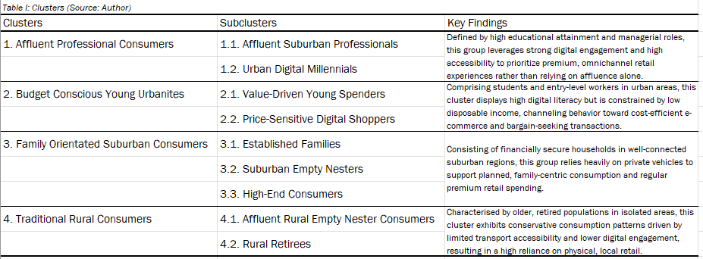
4.1 Descriptions
The first cluster, Affluent Professional Consumers, are characterised by young to middle-aged households with high educational attainment and strong representation in managerial and administrative occupations. Homeownership and mortgage uptake are common, reflecting financial security. The interaction of high socioeconomic capacity, strong digital engagement, and good accessibility to services explains the prevalence of premium, convenience-oriented, and omnichannel retail behaviours, rather than affluence alone. Active lifestyles include engaging in outdoor recreation, cultural amenities and social dining, alongside strong digital engagement. Further segmentation produced two subclusters: Affluent Suburban Professionals and Urban Digital Millennials, highlighting how differences in accessibility and digital engagement shape behaviour within similarly affluent groups.
Budget Conscious Young Urbanites consist predominantly of young adults, students and individuals in routine or entry-level occupations. Single-person and shared rental households are common, with lower disposable income and limited financial resilience. Despite high digital engagement, constrained financial capacity channels behaviour towards cost-efficient online and discount retail. The interaction of socioeconomic precarity and high accessibility encourages frequent, digitally enabled bargain-seeking transactions, distinguishing them from the financially stronger first cluster. Further segmentation produced two subclusters: ‘Value-Driven Young Spenders’ and ‘Price-Sensitive Digital Shoppers’.
Add-Figure-3-here
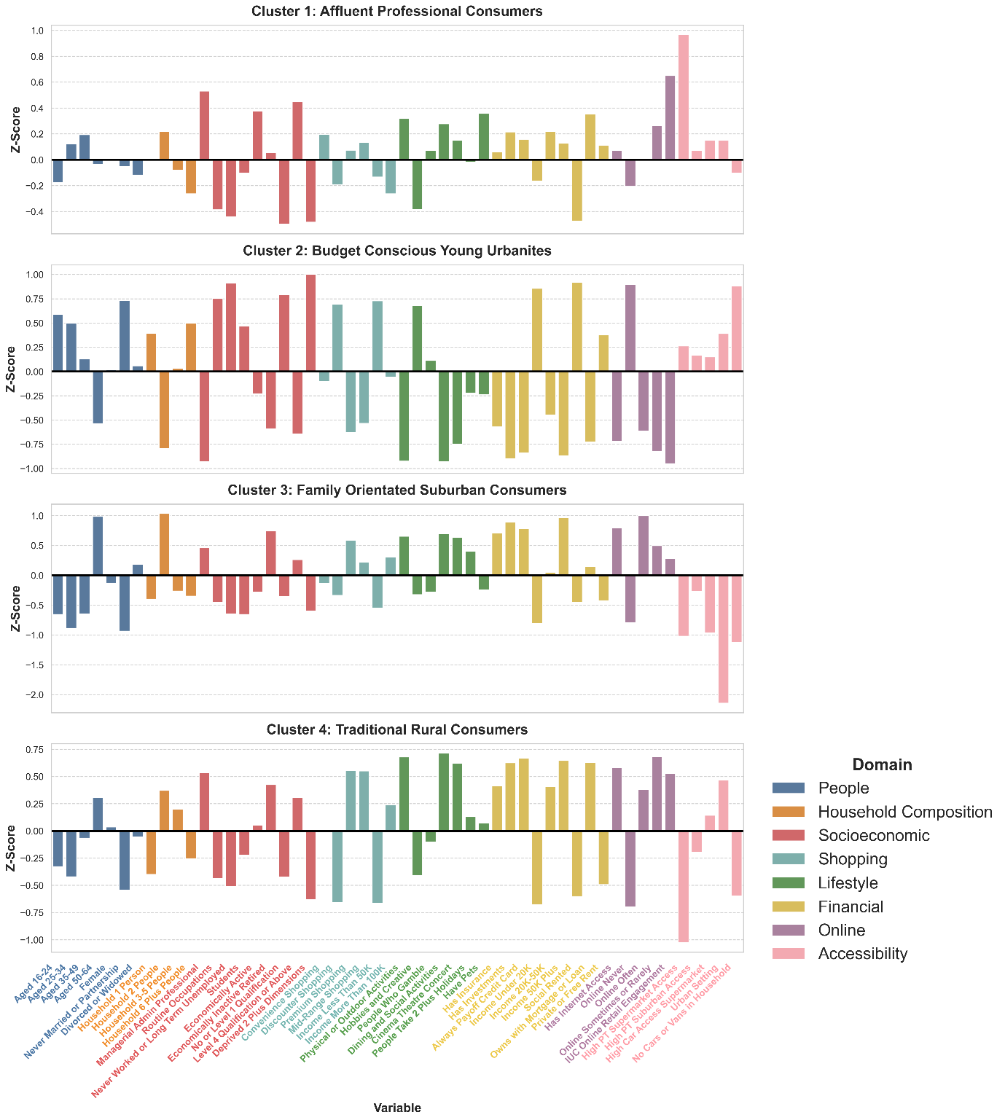
Family-oriented suburban consumers include young families and financially secure mid-life households with strong socioeconomic capacity, reflected in professional jobs and high homeownership. They are car-reliant and reside in well-connected, suburban areas. This combination supports planned, family-oriented consumption, including regular premium retail spending, high online purchasing and participation in social leisure activities. Their residential context supports vehicle-based convenience shopping and family-oriented spending similar to Traditional Rural Consumers, differentiating them from similarly affluent yet more urban-digitally oriented groups. Further segmentation of Family Orientated Suburban Consumers produced three subclusters: ‘Established Families’, ‘Suburban Empty-Nesters and ‘High-End Consumers’.
Traditional Rural Consumers represent older populations, with many retirees living in two-person households. Homeownership and accumulated assets indicate long-term financial security. However, lower accessibility and limited transport constrain choice, meaning that consumption patterns are shaped more by spatial context than by. Reduced digital engagement and reliance on in-person shopping reinforce conservative consumption patterns and loyalty to familiar retail formats. Further segmentation produced two subclusters: ‘Affluent Rural Empty Nester Consumers’ and ‘Rural Retirees’.
Across all clusters, differences arise not from a single attribute but from the interplay between the eight domains. Affluent groups diverge depending on whether accessibility encourages digital convenience or vehicle-oriented retail trips, while younger populations vary in how economic constraints shape value-driven behaviour despite similar environments. Meanwhile, older rural communities demonstrate how isolation, digital engagement, and age jointly affect consumption. Together, these patterns demonstrate that consumer behaviour is shaped by the combined influence of socioeconomic, spatial, and digital domains, validating the conceptual framework underpinning the classification.
4.1 Spatial Distribution
Figure 4 highlights distinct spatial patterns in within the classifications of consumer behaviour, Affluent Professionals Consumers are concentrated in metropolitan areas, particularly apparent in London and in commuter towns. Their presence suggests a high demand for premium retail, and omnichannel shopping experiences. Meanwhile, Budget Conscious Young Urbanites cluster in densely populated, lower-cost urban areas such as Liverpool and Birmingham. These areas exhibit high engagement with digital retail and discount shopping, making them prime locations for e-commerce investment and budget-friendly retail.
Beyond urban areas, Traditional Rural Consumers dominate rural England and Wales, particularly in Southern England, East Anglia, and Yorkshire, where older, less digitally engaged populations rely more on local businesses and essential services. Retail diversity is limited in these areas, suggesting a need for enhanced accessibility and service provision. Meanwhile, Family-Oriented Suburban Consumers are distributed across suburban and semi-rural areas, particularly in the Midlands and Southeast England, showcasing a diverse consumer landscape.

Add-Figure-4-here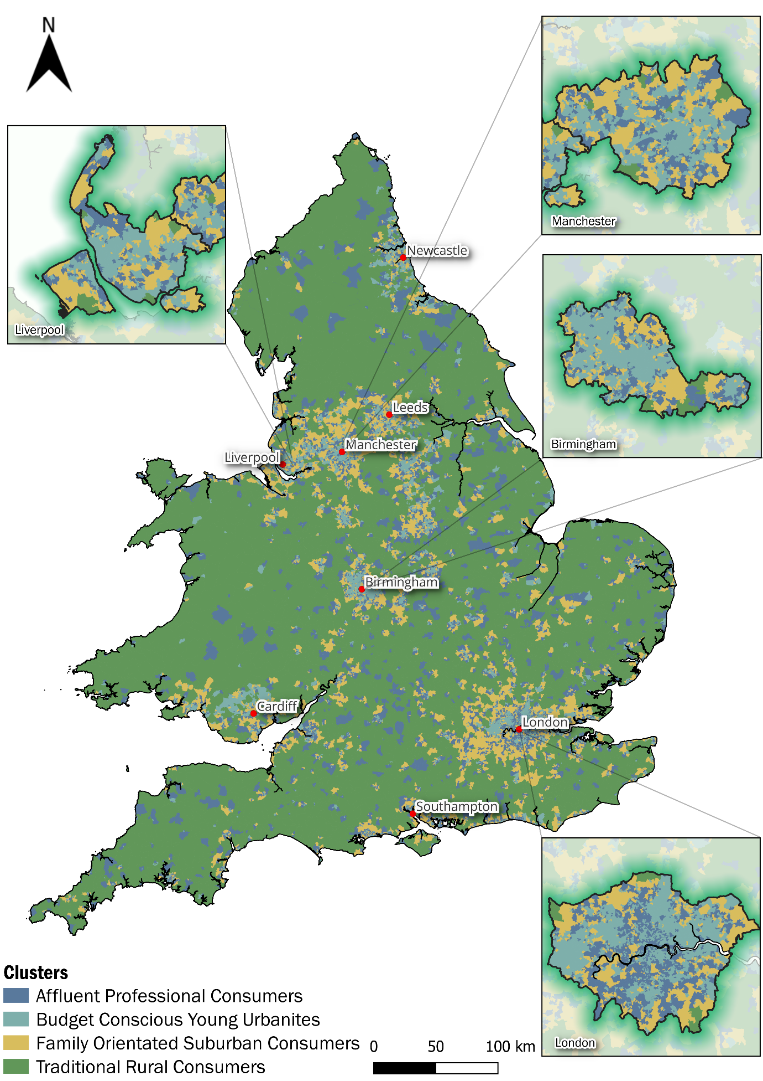

5. Discussion and Conclusion
Consumer behaviour is a multidimensional and complex phenomena to measure, becoming more challenging due to increased digitalisation, experiential retailing and societal changes. This study highlights the critical role of geodemographics as a methodological tool for understanding and measuring consumer behaviour within retail contexts. Such classifications bridge the gap between data and place, enabling decisions in both commercial and public sectors. Leveraging demographic, behavioural, and accessibility data, this research identifies distinct variations in consumer groups and their spatial distributions, employing a rigorous framework for segmentation to develop the first openly available geodemographic segmentation of consumer behaviour. Importantly, this study extends earlier classifications by offering a substantive theoretical advancement: it operationalises a multidimensional framework in which behavioural, spatial, and digital factors are treated as co-determining drivers of consumer behaviour, rather than secondary additions to socioeconomic structure. This integrated perspective moves beyond the conceptual scope of previous classifications and provides new insight into how domains interact to shape retail decision-making. Underpinning the classification is novel spatial microsimulation of a proprietary consumer lifestyle survey, and incorporation of small-area retail measures, which are integrated within the classification alongside other more typical geodemographic data. This is critical for both practitioners and academics as it provides insight which can drive policy, business cases and research in targeted areas.
This analysis demonstrates that consumer behaviour is shaped by a range of factors defining distinct segments and exhibit spatial variation. This research delineates consumer clusters, such as Affluent Suburban Professionals which align with Singleton et al. (2020) as high-income, digitally savvy shoppers who prefer premium goods and online channels. Budget-Conscious Young Urbanites, reflecting (Sharma & Dutta, 2025), prioritise affordability and convenience through e-commerce. Family-Oriented Suburban Consumers, in line with Hossain (2020), favour accessible, mid-range retail suited to family needs. Traditional Rural Consumers face transport barriers (Gauri et al., 2020) but show moderate digital use, suggesting online options can offset limited access. Together, these clusters highlight how place, socioeconomic status, preferences, and digital engagement combine to shape behaviour.
The use of consumer survey data affords precedented insights, which can empower planners, retailer managers and decision-makers to target hyper-local segments. For retail managers, the classification directly supports practical applications like segmentation of local markets to tailor assortments to area-specific preferences (e.g., premium ranges for Affluent Suburban Professionals); optimisation of campaigns by identifying where digital or in-store promotions are likely most effective and strategic decisions around store formats and omnichannel services, informed by the spatial distribution of consumer (Silva et al., 2024; Yang and Hu, 2024). For LSOAs clustered as “Budget-Conscious Young Urbanites,” can be identified through the classification by centre managers for urban regeneration schemes that pair affordable retail offerings with flexible co-working spaces in mixed-use developments (Morgado, 2021). Beyond practice, the classification also functions as a teaching resource in courses on retail geography or urban analytics, presenting how multidimensional consumer data can be operationalised for real-world decision-making.
From a policy and planning perspective, the classification provides an evidence base to support urban planning, transport policy, and high-street revitalisation. Identifying areas dominated by Traditional Rural Consumers, who rely more heavily on physical retail due to accessibility constraints, can inform targeted transport interventions to enhance retail access (Elldér et al., 2022). Henceforth the tool supports policy approaches aimed at digital inclusion, local service resilience, and more equitable access, demonstrating its relevance alongside commercial applications (Silva et al., 2024).
From a commercial perspective, the classification functions as a scalable decision-support tool for retail investment, marketing strategy, and network planning. For retailers, the classification can inform business practices like site selection by identifying underserved consumer segments or areas with high demand for specific retail formats, and can be used in combination with established models of catchment analysis (Dolega et al, 2016; Guan et al., 2025. It can also support targeted omnichannel campaigns for retailers (Radomska et al, 2025). Overall, our classification can be used for policy and business practice to address a broad variety of social and economic challenges.
To conclude, our study presents open, bespoke consumer geodemographic classifications by integrating real-time consumer data, temporal dynamics and cross-national insights. These enhancements will enable better identification of how consumer behaviour is continuing to shift, and the consequences of this on "at-risk" retail areas. The benefits of doing so, relate to more responsive approaches to adapting infrastructure, promoting digital inclusion and aligning retail and services with evolving consumer needs providing a directly usable tool for business practice and policy, enabling evidence-based investment, targeted service delivery, and resilient retail ecosystems.
Despite the robust conceptual and analytical framework for understanding consumer behaviour, certain limitations remain. Firstly, geodemographic classifications inherently simplify the complexity of population characteristics by grouping areas into predefined clusters, this can mask intra-group variation and exclude outliers (Cockings et al. 2020). Our reliance on specific datasets, may introduce biases, as these datasets may not capture the full diversity of consumer experiences. Furthermore, the use of spatial microsimulation and its dependency on the quality and representativeness of the input data is a limitation. While the accuracy of synthetic populations is limited by the quality of benchmark variables and microdata (Singleton et al., 2020), this analysis mitigates those constraints through the comparison against observed patterns. Furthermore, while the use of k-means clustering provided the scalability for national-level analysis, future iterations could explore more advanced alternative clustering methods, like hierarchical or spatially constrained techniques, to more effectively capture latent spatial dependencies.
A further limitation relates to the validation of the classification: while internal validation was conducted through cluster separation metrics and interpretative profiling, the study does not include external validation. Future research could evaluate its predictive utility using expenditure data or benchmark its performance against existing classifications. Moreover, the classification developed here represents a cross-sectional snapshot of behavioural patterns at a specific point in time, despite this we demonstrate how the classification provides an evidence base for practical uses. Future research could extend this framework by incorporating temporal data or integrate these classifications into an agent-based model. This would allow for the simulation of dynamic interactions between consumer and retailers, showing how behaviours evolve as environments change and advancing current research in digital representations of systems (Son et al., 2025).
Notably, while traditional systems like OAC and Mosaic often lead to demographically dominated or non-transparent profiles, our framework explicitly integrates digital engagement and spatial accessibility as co-determining drivers of consumer behaviour. This advancement allows for a more nuanced understanding of how these dimensions intersect to shape retail decision-making beyond what can be inferred from socioeconomic structure alone. Consequently, this provides new substantive theoretical insights into how demographic, social, physical, spatial, digital, and behavioural factors interact to shape consumer choices. The resulting classification therefore offers a flexible, data-rich tool for retailers and planners seeking to align strategies with the specific needs of diverse consumer groups at present, and into the future.

References
Amsl, S., Watson, I., Teller, C. and Wood, S. (2023), "Presenting products on websites – the importance of information quality criteria for online shoppers", International Journal of Retail & Distribution Management, Vol. 51 No. 9/10, pp. 1213-1238. https://doi.org/10.1108/IJRDM-04-2023-0266
Ballantyne, P., Singleton, A., Dolega, L. and Macdonald, J., (2023). “Integrating the who, what, and where of US retail center geographies”. Annals of the American Association of Geographers, Vol. 113(2), pp.488-510.
Barboza, M.H., Giannotti, M., Grigolon, A.B. and Geurs, K.T., (2024). “A comparative analysis of leisure accessibility and equity impacts using location-based and space–time accessibility metrics.” Transportation Research Part A: Policy and Practice, Vol. 190, p.104237.https://doi.org/10.1016/j.tra.2024.104237
Belwal, R., Belwal, S., Morgan, Z. and Al Badi, L.H. (2025), "Profiling consumers for their shopping motivations in modern retail formats in Oman", International Journal of Retail & Distribution Management, Vol. 53 No. 1, pp. 74-93. https://doi.org/10.1108/IJRDM-09-2023-0581
Butterfield, K., Newing, A. and Heppenstall, A., (2020). “Inferring Consumer Type from Loyalty Card Data.”
CDRC (2023). PDV Consumer Lifestyle Survey, Consumer Research Data Centre, available at: https://www.cdrc.ac.uk/ (Accessed: 5 January 2024).
Cockings, S., Martin, D. and Harfoot, A. (2020), "Developing a national geodemographic classification of workplace zones", Applied Spatial Analysis and Policy, Vol. 13 No. 4, pp. 959–983.https://doi.org/10.1007/s12061-020-09337-4
Davies, A., Dolega, L. and Arribas-Bel, D. (2019), "Buy online collect in-store: exploring grocery click&collect using a national case study", International Journal of Retail & Distribution Management, Vol. 47 No. 3, pp. 278-291.https://doi.org/10.1108/IJRDM-01-2018-0025
Dolega, L., Pavlis, M. and Singleton, A. (2016), "Estimating attractiveness, hierarchy and catchment area extents for a national set of retail centre agglomerations", Journal of Retailing and Consumer Services, Vol. 28, pp. 78–90.https://doi.org/10.1016/j.jretconser.2015.08.013
Dolega, L., Rowe, F. and Branagan, E. (2021), "Going digital? The impact of social media marketing on retail website traffic, orders and sales", Journal of Retailing and Consumer Services, Vol. 60, p. 102501.https://doi.org/10.1016/j.jretconser.2021.102501
Elldér, E., Haugen, K. and Vilhelmson, B. (2022), "When local access matters: A detailed analysis of place, neighbourhood amenities and travel choice", Urban Studies, Vol. 59 No. 1, pp. 120–139. https://doi.org/10.1177/00420980209510
Fernie, J. and Sparks, L. (2018). Logistics and retail management: emerging issues and new challenges in the retail supply chain, eds 5, Kogan page publishers, London.
Gale, C.G., Singleton, A., Bates, A.G. and Longley, P.A. (2016), "Creating the 2011 area classification for output areas (2011 OAC)", Journal of Spatial Information Science, Vol. 12, pp. 1–27.http://dx.doi.org/10.5311/JOSIS.2016.12.232
Gray, J., Buckner, L. and Comber, A. (2021), "Extending geodemographics using data primitives: A review and a methodological proposal", International Journal of Geo-Information, Vol. 10 No. 6, p. 386. DOI:10.3390/ijgi10060386
Guan, Y., Cheung, K.S. and Yiu, C.Y., (2025). “Redefining retail catchment with mobile geolocation data: Insights from New Zealand”. Journal of Retailing and Consumer Services, Vol. 82, p.104089. https://doi.org/10.1016/j.jretconser.2024.104089
Harris R (2022) Creating harmonised pseudo-Output Areas for the 2001, 2011 & 2021 Censuses (England and Wales). https://profrichharris.github.io/census/harmonised.
Hossain, M., (2020). “Less is more expensive: income differences in bulk buying.” SSRN, Vol. 1001(48106)
Johnson, O. and Ramirez, S.A. (2020), "The influence of showrooming on Millennial generational cohorts' online shopping behaviour", International Journal of Retail & Distribution Management, Vol. 49 No. 1, pp. 81-103.
Lemon, K.N. and Verhoef, P.C. (2016), "Understanding customer experience throughout the customer journey", Journal of Marketing, Vol. 80 No. 6, pp. 69–96. doi 10.1509/jm.15.0420
Lovelace, R. and Dumont, M., (2017). Spatial microsimulation with R. Chapman and Hall/CRC, eds 1, New York. https://doi.org/10.1080/13658816.2012.719623.
Morgado, S., (2021). “Urban rehabilitation, social innovation, and new working spaces in Lisbon.” Sustainability, Vol. 13(21), p.11925. https://doi.org/10.3390/su132111925.
Negi, P. and Jaiswal, A. (2024). “Impact of financial literacy on consumer financial behavior: A systematic review and research agenda using TCCM framework”. International Journal of Consumer Studies, Vol. 48(3), p.13053. https://doi.org/10.1111/ijcs.13053
Ntounis, N., Saga, R.S., Warnaby, G., Lorono-Leturiondo, M. and Parker, C. (2023). “Reframing high street viability: A review and synthesis in the English context”. Cities, Vol. 134. p.104182. 10.1177/23998083241290343
ONS (2011), Rural-Urban Classification, Office for National Statistics, available at: https://www.ons.gov.uk/ (accessed 19 December 2024).
ONS (2023), 2021 Census Data, Office for National Statistics, available at: https://www.ons.gov.uk/ (accessed 4 January 2025).
Pavlis, M., Dolega, L. and Singleton, A., (2018). “A modified DBSCAN clustering method to estimate retail center extent.” Geographical Analysis, Vol. 50(2), pp.141-161. doi: 10.1111/gean.12138
Radomska, J., Kawa, A., Hajdas, M., Klimas, P. and Silva, S.C. (2025), "Unveiling retail omnichannel challenges: developing an omnichannel obstacles scale", International Journal of Retail & Distribution Management, Vol. 53 No. 13, pp. 1-20. https://doi.org/10.1108/IJRDM-04-2024-0169
Schwendtner, T., Amsl, S., Teller, C. and Wood, S. (2024), "Shopping behaviour of elderly consumers: change and stability during times of crisis", International Journal of Retail & Distribution Management, Vol. 52 No. 13, pp. 1-15. https://doi.org/10.1108/IJRDM-01-2023-0029
Sharma, N. and Dutta, N. (2025), "Generational dynamics of omnichannel customers: analysing shopping preferences across diverse product types", International Journal of Retail & Distribution Management, Vol. 53 No. 4, pp. 312-330. https://doi.org/10.1108/IJRDM-04-2024-0173
Silva SC, Silva FP, Dias JC (2024), "Exploring omnichannel strategies: a path to improve customer experiences". International Journal of Retail & Distribution Management, Vol. 52 No. 1 pp. 62–88. https://doi.org/10.1108/IJRDM-03-2023-0198
Singh, M., Singh, A., Gupta, M. and Reddy, R., (2022). “Leveraging K-Means Clustering and Hierarchical Agglomerative Algorithms for Scalable AI-Driven Customer Segmentation.” Journal of AI ML Research, Vol. 11(7), pp.1-23
Singh, P., Khoshaim, L., Nuwisser, B. and Alhassan, I., (2024). “How Information Technology (IT) Is Shaping Consumer Behavior in the Digital Age: A Systematic Review and Future Research Directions.” Sustainability, Vol. 16(4), p.1556. https://doi.org/10.3390/su16041556
Singleton, A.D. and Spielman, S.E., (2014). “The past, present, and future of geodemographic research in the United States and United Kingdom.” The Professional Geographer, Vol. 66(4), pp.558-567. 10.1080/00330124.2013.848764
Singleton, A., Longley, P. and Adnan, M. (2019). Internet User Classification for 2019. Available at: https://www.cdrc.ac.uk/data/ (Accessed: 5 January 2025).

Singleton, A., Alexiou, A. and Savani, R., (2020). “Mapping the geodemographics of digital inequality in Great Britain: An integration of machine learning into small area estimation.” Computers, Environment and Urban Systems, Vol. 82, p.101486. https://doi.org/10.1016/j.compenvurbsys.2020.101486
Son, H., Jang, J., Park, J., Balog, A., Ballantyne, P., Kwon, H.R., Singleton, A. and Hwang, J., (2025). “Leveraging Advanced Technologies for (Smart) Transportation Planning: A Systematic Review.” Sustainability, Vol. 17(5), p.2245.https://doi.org/10.3390/su17052245
Stevens, A., Cho, C., Metin, Ç., Kong, X. and Boland, M., (2021). “The Food Retail Landscape Across Rural America” (No. 311337). United States Department of Agriculture. Available at: http://www.ers.usda.gov/publications/pub-details/?pubid=101355. Accessed January 15, 2025.
Sturley, C., Newing, A. and Heppenstall, A., (2018). “Evaluating the potential of agent-based modelling to capture consumer grocery retail store choice behaviours”. The International Review of Retail, Distribution and Consumer Research, Vol. 28(1), pp.27-46. 10.1080/09593969.2017.1397046
Tangri, K. and Yu, H. (2023), "Why buy used? Motivators and barriers for re-commerce luxury fashion", International Journal of Retail & Distribution Management, Vol. 51 No. 9/10, pp. 1095-1114. https://doi.org/10.1108/IJRDM-10-2022-0417
UBDC (2023), Accessibility Indicators, Urban Big Data Centre, available at: https://data.ubdc.ac.uk/datasets/accessibility-indicators (accessed 19 December 2024).

White, J.T., Hickie, J., Orr, A., Jackson, C. and Richardson, R., (2023). “The experience economy in UK city centres: A multidimensional and interconnected response to the ‘death of the high street’?” Urban Studies, Vol. 60(10), pp.1833-1852. https://doi.org/10.1177/00420980221143043

Yang, Y., Dolega, L. and Darlington-Pollock, F., (2023). “Ageing in Place Classification: Creating a geodemographic classification for the ageing population in England.” Applied spatial analysis and policy, Vol. 16(2), pp.583-623. https://doi.org/10.1007/s12061-022-09490-y7
Yang Z, Hu D (2024), "Digital technology-empowered omnichannel integration: a review and research agenda". International Journal of Retail & Distribution Management, Vol. 52 No. 4 pp. 407–424. https://doi.org/10.1108/IJRDM-09-2023-0560

